A few months ago there is a publication, a quite popular post on [Clustering the Bible](http://blog.ephorie.de/clustering-the-bible)… one well known *clustering* algorithm is *k-means*. If you want to learn how *k*-means works and how to apply it in a real-world example, read on…

*k*-means (not to be confused with *k-nearest neighbours* or *KNN*: [Teach R to read handwritten Digits with just 4 Lines of Code](http://blog.ephorie.de/teach-r-to-read-handwritten-digits-with-just-4-lines-of-code)) is a simple, yet often very effective *unsupervised learning* algorithm to find similarities in large amounts of data and cluster them accordingly. The *k* stands for the number of clusters which has to be set beforehand.

The guiding principles are:

* The *distance* between data points within clusters should be as small as possible.
* The distance of the *centroids* (= centre of the clusters) should be as big as possible.

Because there are too many possible combinations of all possible clusters comprising all possible data points *k*-means follows an *iterative* approach:

1. Initialization: assign clusters randomly to all data points
2. E-step (for expectation): assign each observation to the “nearest” (based on *Euclidean distance*) cluster
3. M-step (for maximization): determine new centroids based on the mean of assigned objects
4. Repeat steps 3 and 4 until no further changes occur

As can be seen above *k*-means is an example of a so-called *expectation-maximization algorithm*.

To implement *k*-means in R we first assign some variables and define a helper function for plotting the steps:

n <- 3 # no. of centroids

set.seed(1415) # set seed for reproducibility

M1 <- matrix(round(runif(100, 1, 5), 1), ncol = 2)

M2 <- matrix(round(runif(100, 7, 12), 1), ncol = 2)

M3 <- matrix(round(runif(100, 20, 25), 1), ncol = 2)

M <- rbind(M1, M2, M3)

C <- M[1:n, ] # define centroids as first n objects

obs <- length(M) / 2

A <- sample(1:n, obs, replace = TRUE) # assign objects to centroids at random

colors <- seq(10, 200, 25)

clusterplot <- function(M, C, txt) {

plot(M, main = txt, xlab = "", ylab = "")

for(i in 1:n) {

points(C[i, , drop = FALSE], pch = 23, lwd = 3, col = colors[i])

points(M[A == i, , drop = FALSE], col = colors[i])

}

}

clusterplot(M, C, "Initialization")

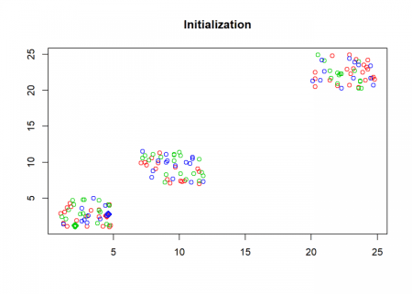  
Here comes the *k*-means algorithm as described above:

repeat {

# calculate Euclidean distance between objects and centroids

D <- matrix(data = NA, nrow = n, ncol = obs)

for(i in 1:n) {

for(j in 1:obs) {

D[i, j] <- sqrt((M[j, 1] - C[i, 1])^2 + (M[j, 2] - C[i, 2])^2)

}

}

O <- A

## E-step: parameters are fixed, distributions are optimized

A <- max.col(t(-D)) # assign objects to centroids

if(all(O == A)) break # if no change stop

clusterplot(M, C, "E-step")

## M-step: distributions are fixed, parameters are optimized

# determine new centroids based on mean of assigned objects

for(i in 1:n) {

C[i, ] <- apply(M[A == i, , drop = FALSE], 2, mean)

}

clusterplot(M, C, "M-step")

}

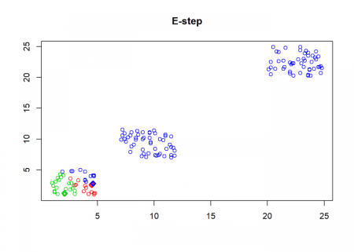

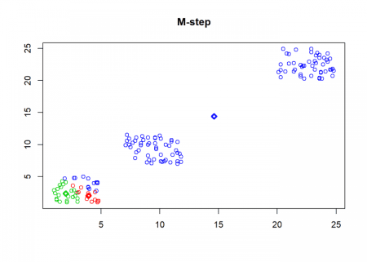

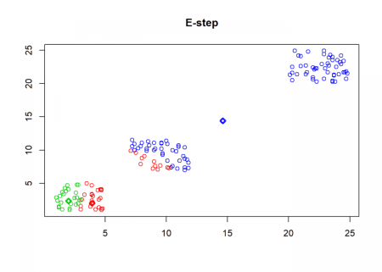

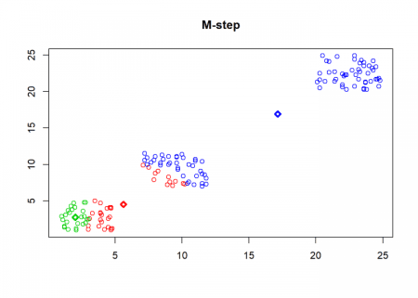

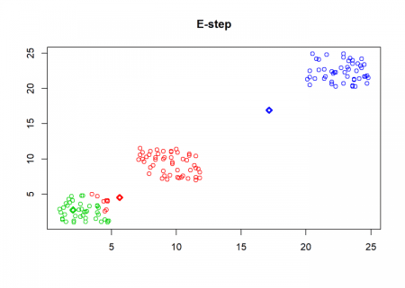

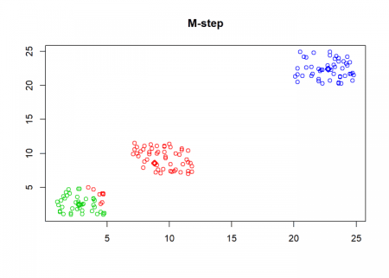

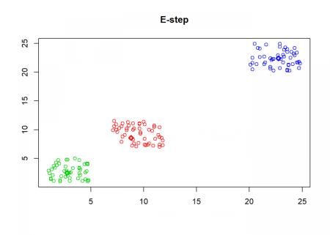

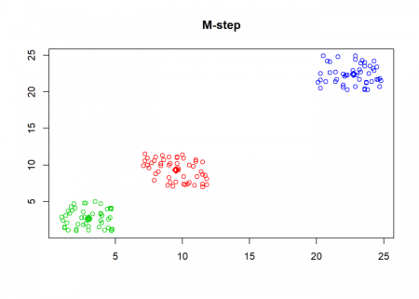

As can seen the clusters wander slowly but surely until all three are stable. We now compare the result with the k-means function in Base R:

cl <- kmeans(M, n)

clusterplot(M, cl$centers, "Base R")

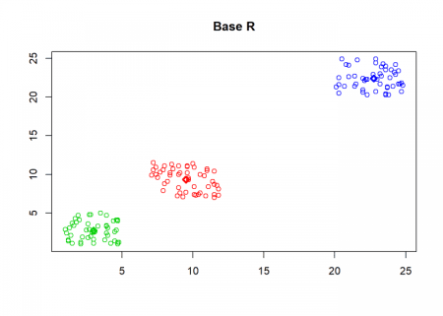

(custom <- C[order(C[ , 1]), ])

## [,1] [,2]

## [1,] 3.008 2.740

## [2,] 9.518 9.326

## [3,] 22.754 22.396

(base <- cl$centers[order(cl$centers[ , 1]), ])

## [,1] [,2]

## 2 3.008 2.740

## 1 9.518 9.326

## 3 22.754 22.396

round(base - custom, 13)

## [,1] [,2]

## 2 0 0

## 1 0 0

## 3 0 0

As you can see, the result is the same!

Now, for some real-world application: clustering wholesale customer data. The data set refers to clients of a wholesale distributor. It includes the annual spending on diverse product categories and is from the renowned *UCI Machine Learning Repository* (I guess the category “Delicassen” should rather be “Delicatessen”).

Have a look at the following code:

data <- read.csv("<https://archive.ics.uci.edu/ml/machine-learning-databases/00292/Wholesale> customers data.csv", header = TRUE)

head(data)

## Channel Region Fresh Milk Grocery Frozen Detergents_Paper Delicassen

## 1 2 3 12669 9656 7561 214 2674 1338

## 2 2 3 7057 9810 9568 1762 3293 1776

## 3 2 3 6353 8808 7684 2405 3516 7844

## 4 1 3 13265 1196 4221 6404 507 1788

## 5 2 3 22615 5410 7198 3915 1777 5185

## 6 2 3 9413 8259 5126 666 1795 1451

set.seed(123)

k <- kmeans(data[ , -c(1, 2)], centers = 4) # remove columns 1 and 2, create 4 clusters

(centers <- k$centers) # display cluster centers

## Fresh Milk Grocery Frozen Detergents_Paper Delicassen

## 1 8149.837 18715.857 27756.592 2034.714 12523.020 2282.143

## 2 20598.389 3789.425 5027.274 3993.540 1120.142 1638.398

## 3 48777.375 6607.375 6197.792 9462.792 932.125 4435.333

## 4 5442.969 4120.071 5597.087 2258.157 1989.299 1053.272

round(prop.table(centers, 2) * 100) # percentage of sales per category

## Fresh Milk Grocery Frozen Detergents_Paper Delicassen

## 1 10 56 62 11 76 24

## 2 25 11 11 22 7 17

## 3 59 20 14 53 6 47

## 4 7 12 13 13 12 11

table(k$cluster) # number of customers per cluster

##

## 1 2 3 4

## 49 113 24 254

One interpretation could be the following for the four clusters:

1. Big general shops
2. Small food shops
3. Big food shops
4. Small general shops

As you can see, the interpretation of some clusters found by the algorithm can be quite a challenge. If you have a better idea of how to interpret the result please tell me in the comments below!